**HandsMen Threads: Elevating Men's Fashion with Salesforce**

# ABSTRACT

This project focuses on developing a tailored Salesforce CRM solution for HandsMen Threads, a prominent name in the men’s fashion industry. The main objective was to simplify and automate critical business operations — including customer management, order processing, inventory tracking, and marketing coordination — to support the company’s growth. By harnessing the capabilities of Salesforce’s cloud platform, we built an efficient system that ensures accurate data handling, smooth workflows, and real-time visibility across departments. The customized CRM incorporates purpose-built objects, automated processes, validation rules, scheduled email notifications, and Apex customizations. Together, these components help boost customer interaction, drive sales performance, minimize inventory issues, and deliver comprehensive insights into overall business performance.

**Objective**

Our main goal was to design and deploy a customized Salesforce CRM for HandsMen Threads that streamlines day-to-day operations and enhances customer satisfaction.

Specifically, the project aimed to:

* Automate repetitive activities such as order confirmation emails, loyalty tier updates, and low-stock alerts.
* Ensure precise and consistent data input through strong validation rules.
* Provide teams with real-time insights into inventory, customer engagement, and sales trends.
* Strengthen collaboration and communication between sales, marketing, and inventory departments.
* Offer personalized customer experiences with the help of automated notifications and loyalty initiatives.

# 

**TECHNOLOGY DESCRIPTION**

Let's talk about the Salesforce magic we used for this project:

# Salesforce Platform

Think of Salesforce as our central nervous system. It's a cloud-based Customer Relationship Management (CRM) platform that helps us manage everything about our customers. It's packed with tools to automate tasks, make customer service amazing, optimize marketing campaigns, and boost sales. We leveraged both its user-friendly drag-and-drop features and its powerful coding capabilities (like Apex and Flows) for the more complex stuff.

# Custom Objects

These are like our custom-built digital filing cabinets within Salesforce, specifically designed to store HandsMen Threads' unique information:

* **Customer__c**: This is where we keep all the juicy details about each customer – personal info, contact details, and their current loyalty status.
* **Product__c**: Here, we manage every single product, from its name and description to its price and how many we have in stock.
* **Order__c**: This object meticulously records every customer order, linking it back to the specific customer and products involved, along with the order date, total amount, and quantity.
* **Marketing_Campaign__c**: We use this to track all our marketing initiatives and promotions, helping us see what's working best.

# Tabs

Think of Tabs as easy-to-find shortcuts. We created custom tabs for each of our custom objects (like a "Products" tab or an "Orders" tab) so our team can quickly view, create, and manage records directly within the "HandsMen Threads" app.

# Custom App

We built a custom Lightning App, which we lovingly named "HandsMen Threads." This app is our team's central command center, bringing all the relevant tabs (Customer, Order, Product, Inventory, Campaign, Reports) into one place for a super smooth workflow.

# Profiles & Roles

These are all about controlling who sees what and who can do what:

* **Profiles**: These define a user's permissions, what objects and fields they can see, and how their screens look. We set up custom profiles, like a "HandsMen Sales Profile," specifically tailored to different job functions.
* **Roles**: Roles manage data visibility based on our company's hierarchy. So, our "Sales Manager" might see all sales data, while a "Sales Representative" only sees their own, but everyone knows who reports to whom.

# Permission Sets

These are like bonus permission packs. We use them to give users extra access to specific tools or functions beyond what their standard profile allows, giving us even finer control without messing with their main profile settings.

# Validation Rules

These are our data quality guardians! Validation rules check the information users enter to make sure it meets our standards before it's saved. For instance:

* We made sure email addresses look like email addresses (e.g., must contain "@gmail.com").
* We prevent anyone from saving an order if it would make our product stock go into the negative.

# Email Templates & Alerts

These help us communicate consistently and automatically:

* **Email Templates**: These are pre-designed email layouts (like our "Order Confirmation" template) that ensure our messages always look professional and consistent.
* **Email Alerts**: These are automatic email notifications that fire off based on certain conditions, like when a new order comes in or a customer's loyalty status changes.

# Flows

Flows are our visual automation tools – they let us build complex business logic without writing a single line of code! Here are some key flows we built:

1. **Email Notification Flow**: This one automatically sends an order confirmation email to the customer the moment a new order is placed.

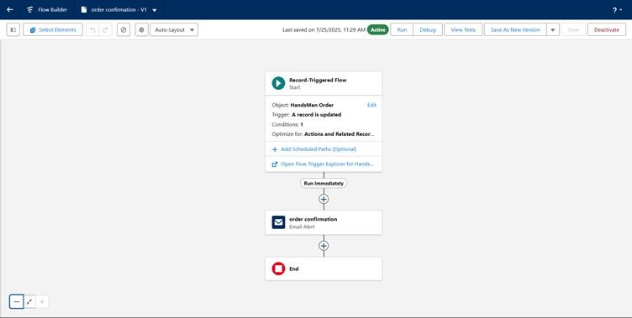

1. **Stock Update Flow**: When an order is created or changed, this flow automatically updates the product's available stock.

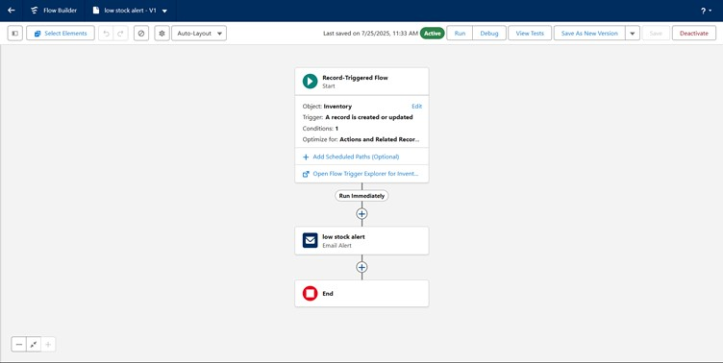

1. **Scheduled Loyalty Update Flow**: This flow runs every day (say, at midnight) to check and update customer loyalty statuses based on their total purchase amounts.

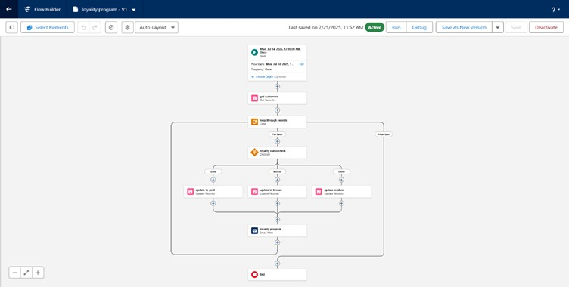

# Apex

Apex is Salesforce's programming language, used when we need to build specific or complex business logic that the standard tools can't handle. Our Apex triggers include:

* **Order Total Trigger**: This automatically calculates and updates the Total_Amount__c field on an order based on the quantity and unit price. Super handy!
* **Stock Deduction Trigger**: This works behind the scenes to ensure that stock is accurately reduced from a product once an order is confirmed. It works hand-in-hand with our validation rules to prevent overselling.
* **Loyalty Status Trigger**: This dynamically updates a customer's

Loyalty_Status__c field in real-time, based on their cumulative purchase history.

**DETAILED PROJECT EXECUTION**

# 1. Salesforce Developer Org Setup

We set up a new Salesforce Developer Org at<https://developer.salesforce.com/signup>, our main environment for all development work.

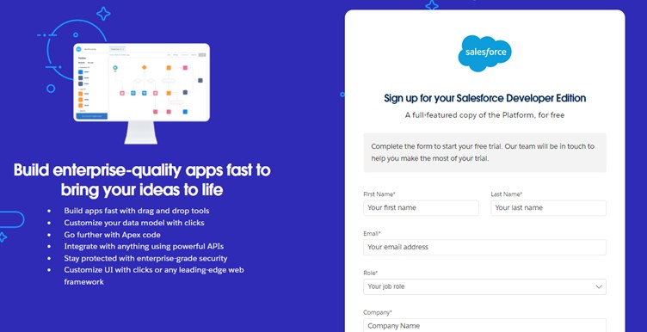

# 2. Custom Object Creation

We built the core data structure by creating custom objects and their fields to store all essential business information:

* **HandsMen Customer (Customer__c)**: For customer details (Name, Email, Phone, Address, Loyalty_Status__c).
* **HandsMen Product (Product__c)**: For product information (Name, Description, Unit_Price__c, Stock__c).
* **HandsMen Order (Order__c)**: For customer orders (Date, Quantity__c, Total_Amount__c, linked to Customer and Product).
* **Marketing Campaign (Marketing_Campaign__c)**: For promotional activities.

# 3. Custom Lightning App

We created the "HandsMen Threads" Lightning App. This app pulls together all relevant tabs (Customer, Order, Product, Inventory, Campaign, Reports) to create a single, easy-to-use workspace for our teams.

# 4. Validation Rules

We implemented rules to ensure data quality:

* **Product Stock**: Prevents Stock__c from being less than zero.
* **Customer Email**: Requires the Email field to contain "@gmail.com".

# 5. User Profiles & Roles

We configured specific profiles and roles to manage user access and data visibility:

* **Profiles**: Cloned "Standard User" to create profiles like "HandsMen Sales Profile."
* **Roles**: Defined a hierarchy including "Sales Manager," "Inventory Manager," etc., controlling data visibility based on responsibilities.

# 6. User Creation

We created new users and assigned them to their respective roles and profiles (e.g., Niklaus Mikaelson for Sales, Kol Mikaelson for Inventory) to demonstrate the system's multi-user capabilities.

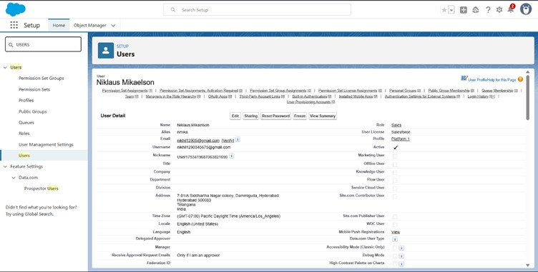

# 7. Email Templates

Custom email templates were designed for automated and consistent communication, such as "Order Confirmation" and "Loyalty Status Update."

**8. Flow Implementations**

1. **Email Notification Flow (Record-Triggered)**

Sends an order confirmation email to the customer when a new order is created.

1. **Stock Update Flow (Record-Triggered)**

Automatically updates product stock when an order is created or changed.

1. **Scheduled Loyalty Update Flow (Scheduled-Triggered)**

Runs daily to update customer loyalty status based on their total purchase amounts.

**9. Apex Triggers**

# a. Order Total Trigger (OrderTrigger)

Automatically calculates and updates the total amount of an order based on quantity and unit price.

**b. Stock Deduction Trigger (ProductStockUpdateTrigger)** Ensures product stock is correctly reduced after an order.

# c. Loyalty Status Trigger (CustomerLoyaltyUpdateTrigger)

Updates a customer's loyalty status in real-time based on their cumulative purchase history.

# PROJECT DEMONSTRATION: A Real-World Example

To show you how all this magic comes together, let's walk through a typical customer experience with HandsMen Threads:

1. **Customer Registration**:
   * Imagine a new customer, "John Doe," walks into our store.
   * A sales rep quickly goes to the "HandsMen Customer" tab in our app and clicks "New."
   * They enter John's details: Name, Phone, and Email (let's say

"john.doe@gmail.com").

* + **Validation Rule in Action**: If the rep accidentally types

"john.doe@yahoo.com," the system immediately pops up an error: "Please enter a valid Gmail address." This keeps our data clean!

* + Once everything's correct, John Doe is officially in our system.

1. **Product Setup**:
   * Meanwhile, our inventory manager ensures all products are correctly listed

under the "HandsMen Product" tab.

* + For example, a "Men's Suit - Classic Blue" is listed with a price of $500 and 10

in stock.

1. **Order Placement**:
   * John Doe decides he loves the "Men's Suit - Classic Blue" and wants one. o The sales rep creates a new order under the "HandsMen Order" tab.
   * They link John Doe to the order, select the "Men's Suit - Classic Blue," and enter

a quantity of 1.

* **Apex Trigger in Action**: The moment the order is saved, our OrderTotalTrigger automatically calculates and fills in the Total_Amount__c as $500 (1 suit * $500). No manual math needed!
* **Email Notification Flow in Action**: Almost instantly, the Email Notification Flow kicks in and sends John Doe an "Order Confirmation" email to his Gmail address, detailing his purchase.

1. **Inventory Update**:
   * **Stock Update Flow in Action**: Right after the order is saved, the "Men's Suit - Classic Blue" stock automatically updates from 10 to 9.
   * **Validation Rule in Action**: What if the rep tried to order 11 suits when only 10 were left? Our validation rule on the Product__c would block the order, preventing us from selling something we don't have!
2. **Loyalty Status Update**:
   * **Apex Trigger in Action**: As soon as John Doe's order is processed and his Total_Amount__c updates, our CustomerLoyaltyUpdateTrigger recalculates his total purchases. If this purchase pushes him over a loyalty threshold (e.g., becoming a "Silver Member"), his Loyalty_Status__c on his customer record instantly updates.
   * **Scheduled Flow in Action**: Just to be extra sure, our "Scheduled Loyalty Update" flow also runs daily. So, even if there were any missed updates, it would catch them and ensure all customer loyalty statuses are spot-on.

This whole process showcases how our Salesforce CRM solution for HandsMen Threads seamlessly manages everything, from greeting a new customer to processing their order and nurturing their loyalty!

**SCREENSHOTS**

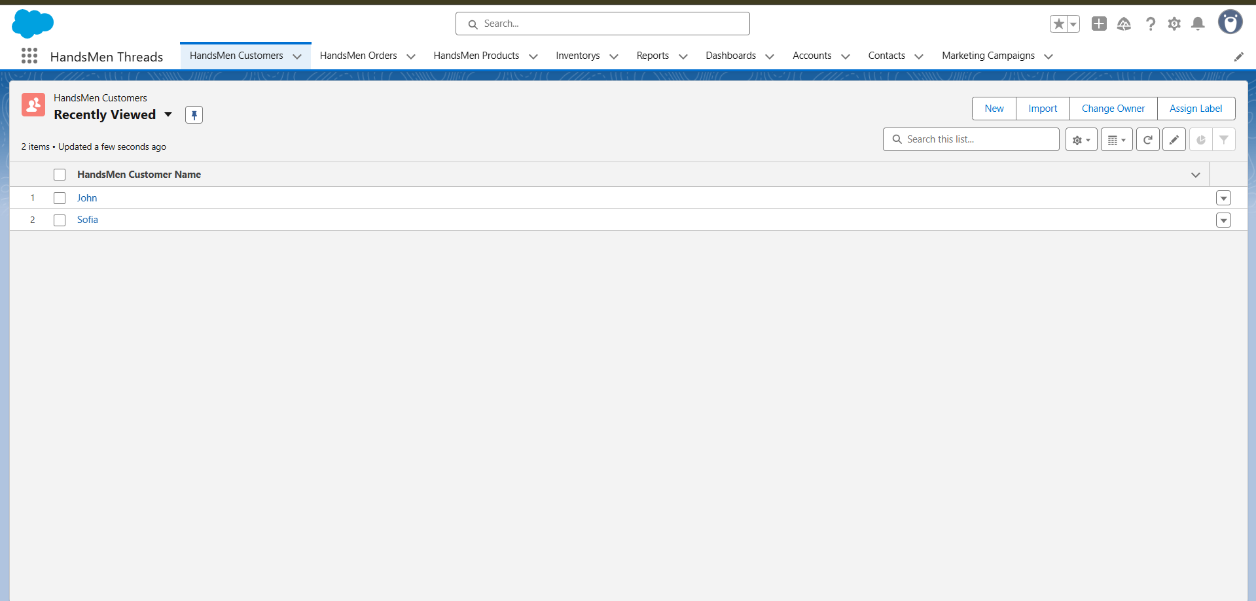

**Fig: Custom App for HandsMen Threads**

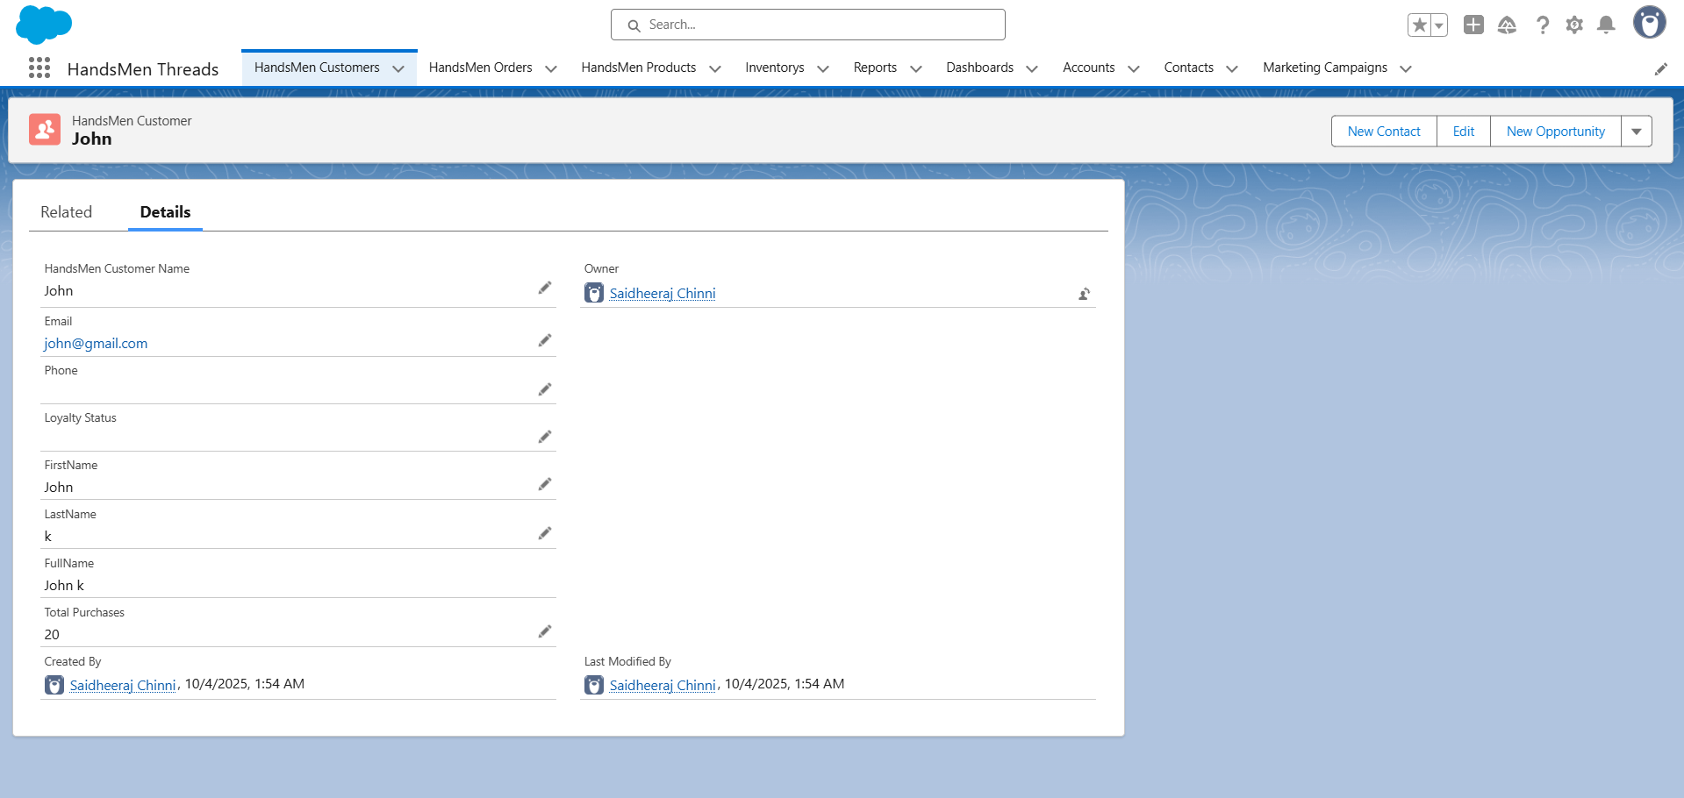

## Fig: Customer Creation in HandsMen Threads

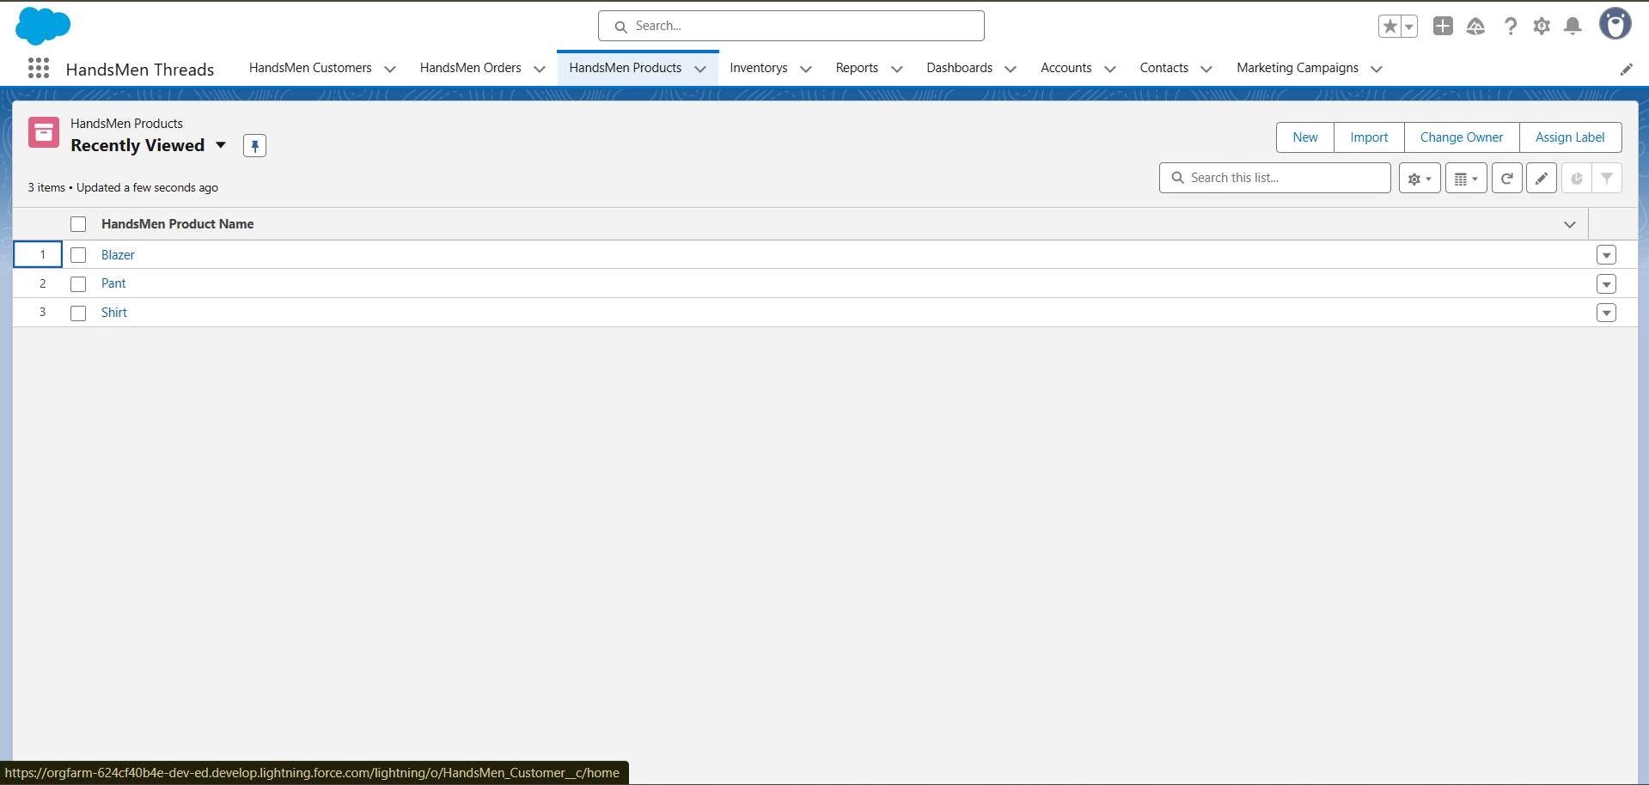

**Fig: Product List View**

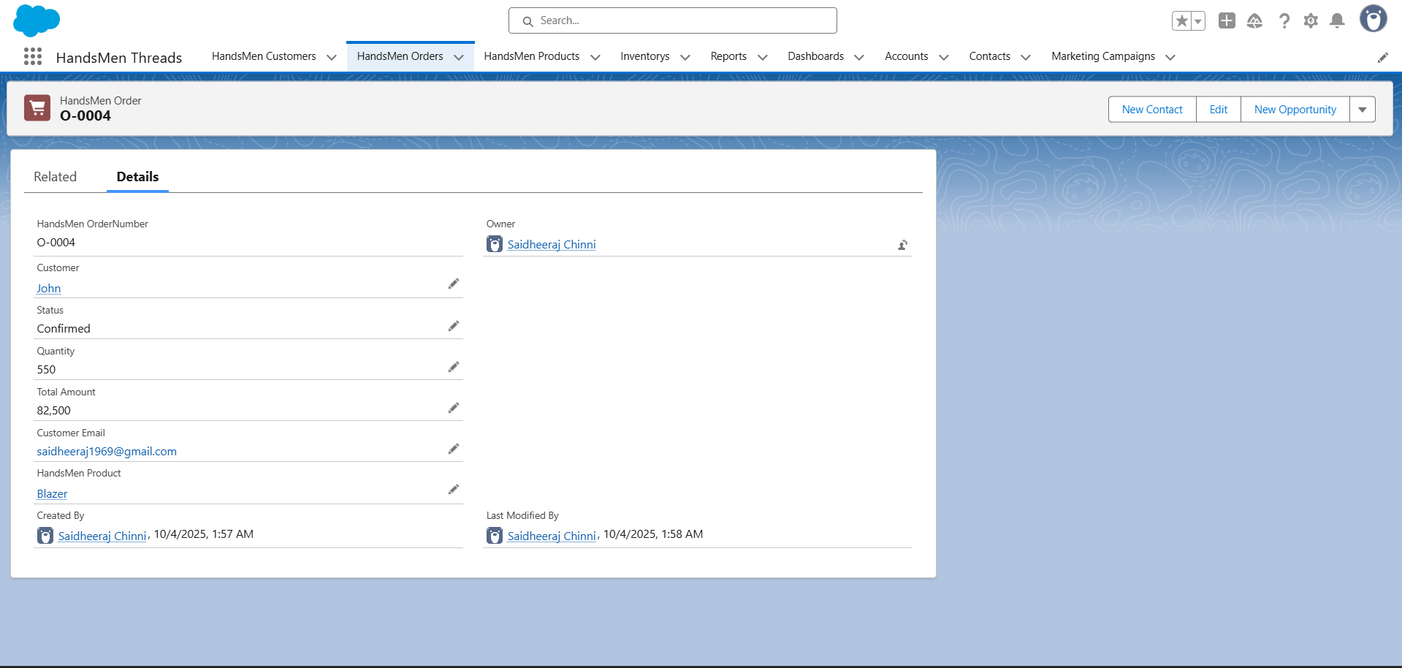

**Fig: New Order Creation Page**

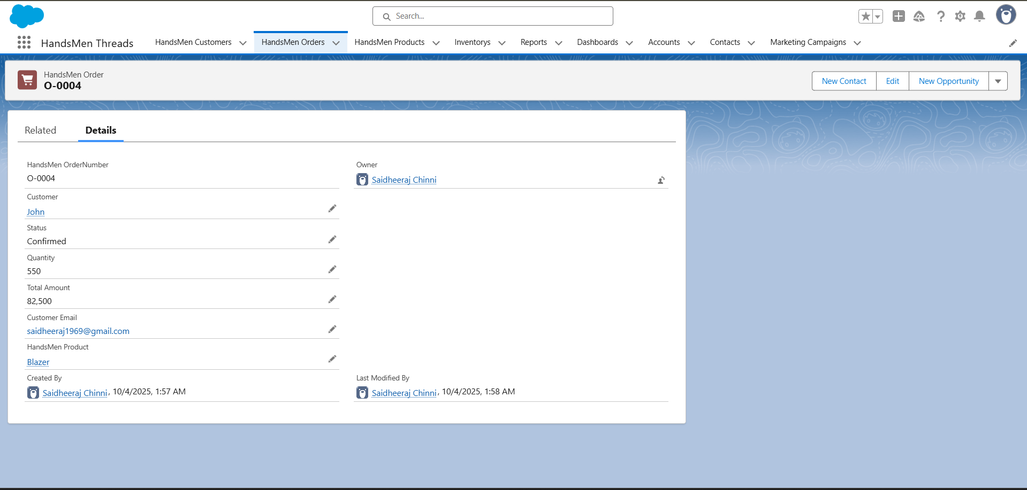

**Fig: Order Confirmation**

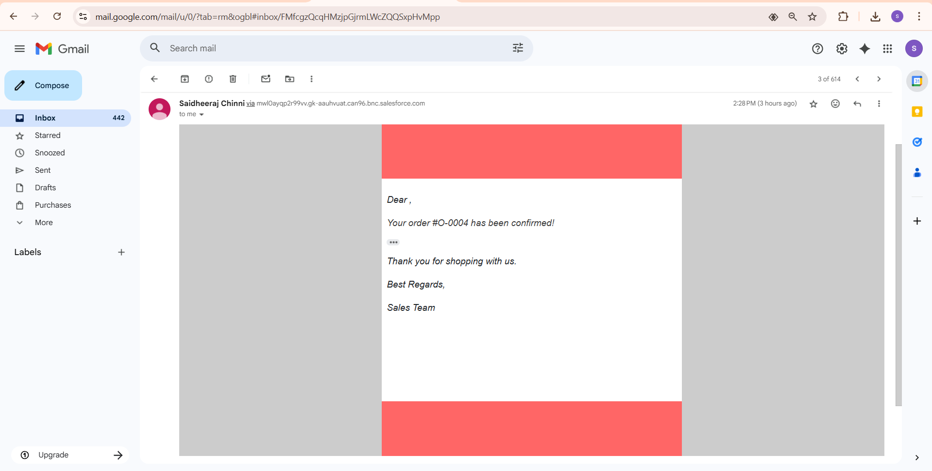

## Fig: Order Confirmation Email Sent to Customer

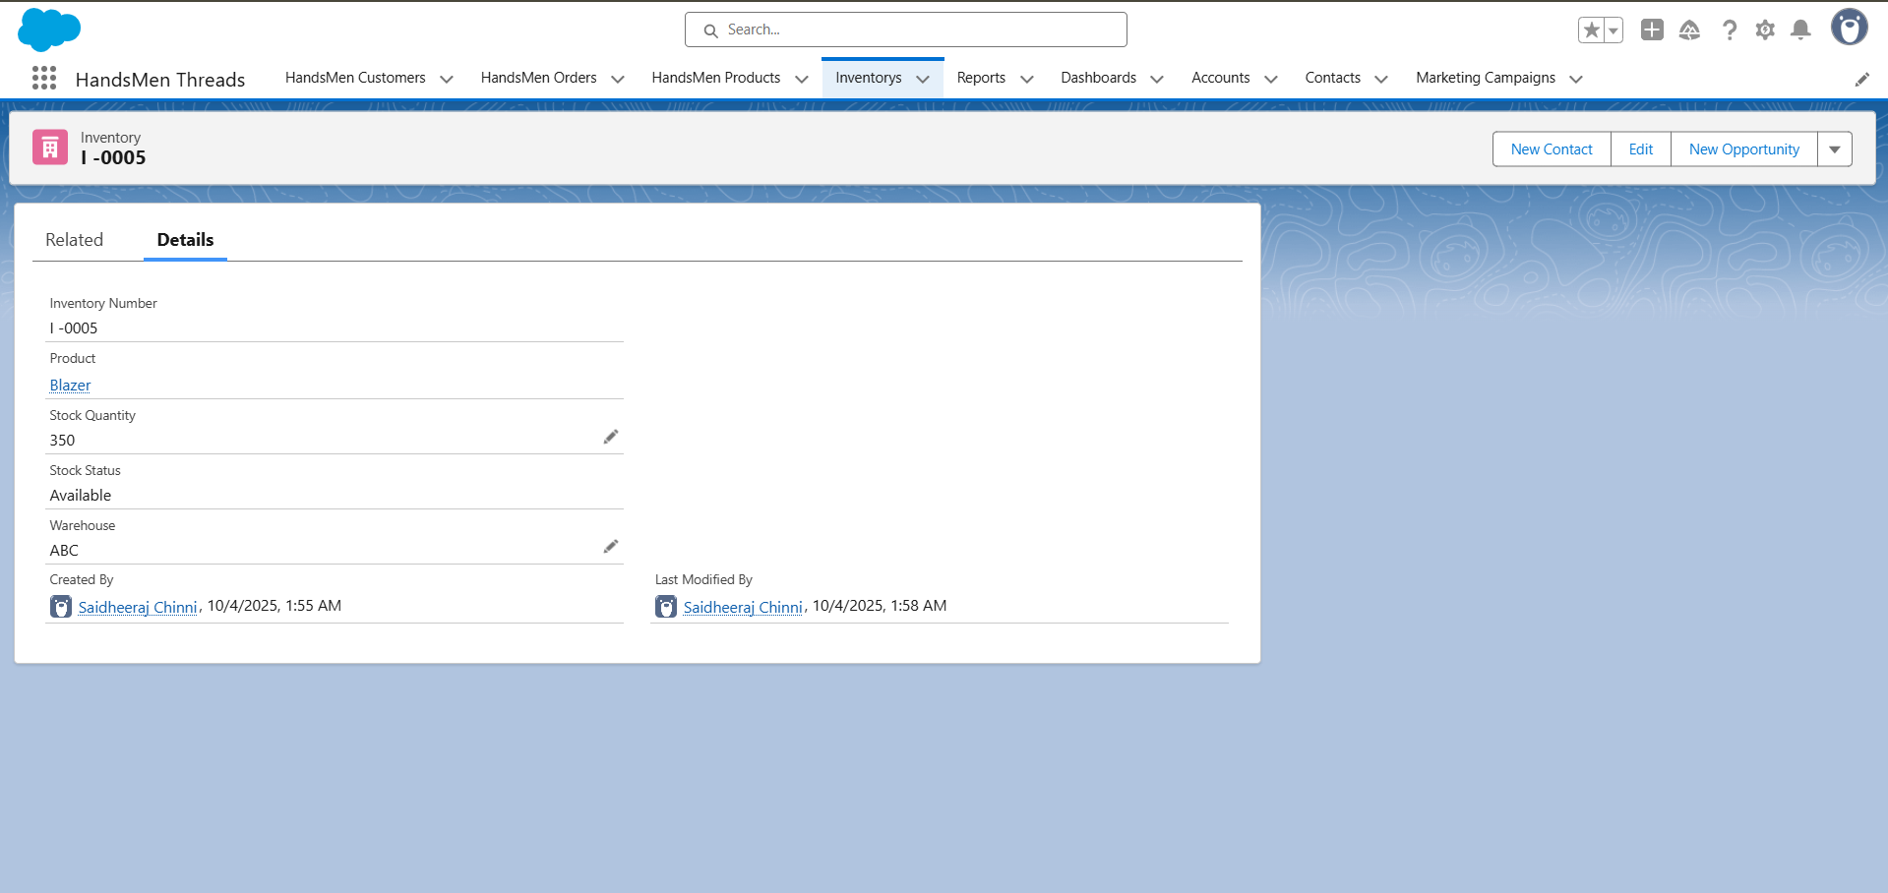

**Fig: Inventory Creation**

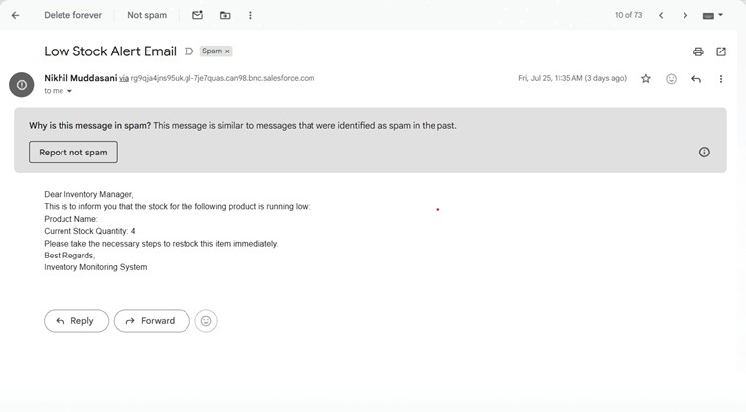

**Fig: Low Stock Alert**

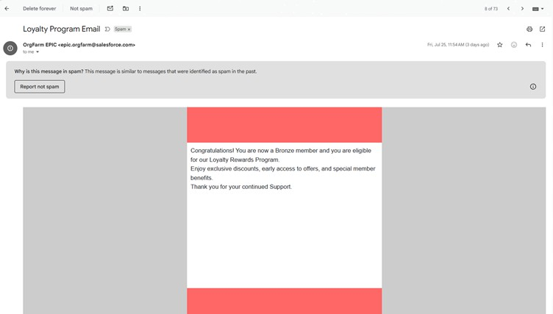

**Fig: Customer Record Showing Updated Loyalty Status**

**CONCLUSION**

Our Salesforce CRM for HandsMen Threads is a game-changer. It smoothly handles our core business operations, builds stronger customer relationships, and keeps our data incredibly accurate across sales, inventory, and marketing. By harnessing Salesforce's powerful features – from custom objects and smart automations (flows) to strict data checks (validation rules), timely alerts, and custom code (Apex) – we've created an integrated platform. This gives HandsMen Threads instant insights, helps us make smarter decisions, and builds a solid foundation for growth and even more amazing customer experiences down the road.

# FUTURE SCOPE

We're not stopping here! Here are some exciting ways we can make the HandsMen Threads CRM even better:

* **Customer Portal**: Imagine a dedicated online portal where customers can log in, view their past orders, track their loyalty points, update their details, and even get support – all on their own!
* **Mobile App Development**: We can build a slick mobile app for our in-store teams using the Salesforce Mobile SDK. This would let them manage inventory, process orders, and access customer info right from their phones or tablets.
* **Advanced Reports & Dashboards**: Let's create some jaw-dropping sales and inventory dashboards in Salesforce! These visual tools would give us deeper insights into our performance, help us spot trends, and guide our strategic decisions.
* **AI-Powered Recommendations (Salesforce Einstein)**: We could integrate Salesforce Einstein to offer personalized product recommendations to customers. Think about it: suggestions based on their past purchases or what similar customers love – a real sales booster!
* **Messaging Integration**: Connecting with popular messaging apps like WhatsApp or SMS would let us send real-time order confirmations, shipping updates, loyalty program news, and even personalized marketing messages directly to our customers' phones.